**Why Scripting On Your Okuma Control**

Automating tasks and accessing API functions on your Okuma machine tool *is possible without* downloading Microsoft Visual Studio or spending weeks learning Windows programming!

IronPython scripting is a lightweight alternative which will allow you to use the Okuma THINC API to access machine data and wait for events, write Excel files, send emails and texts and a lot more. Using IronPython and a few simple tools, you can utilize the power of your P-series control to eliminate repetitive tasks, reduce entry/calculation errors and capture data exactly the way you want it.

Links online frequently change.

At time of writing, all links in this tutorial were verified to work. If you run across a link that doesn't work, please let us know so we can fix it!

This tutorial will cover the following topics. Each concept builds on the previous, so it is strongly suggested you work through each item before moving to the next.

**Downloading IronPython and the Okuma THINC API**

Nothing you're going to download needs to be installed but you *will* want to keep it all together. I keep a full scripting setup on a USB stick in a folder called IronPythonScripting so I can easily move it to machine tools. 2GB should be more than sufficient.

**Getting IronPython**

IronPython is a scripting and programming language which can use .NET libraries including the Okuma THINC API and the .NET Framework. It's the core of what we'll be working with.

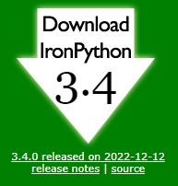You'll want to visit [the IronPython homepage at ironpython.net](http://ironpython.net) to download the official version of IronPython.

Click the Download IronPython link. (At time of writing, March 2023, the newest version is 3.4 and the download link looks like the screenshot to the right.)

You will be taken to the IronPython GitHub, and you want to download and install the .msi file.

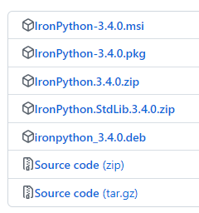

Find the path where IronPyton was installed (it will likely be C:\Program Files\IronPython 3.4) and copy the entire folder to the IronPythonScripting folder on your USB stick.

**Getting the Okuma THINC API**

The Product Engineering Group at Okuma maintains a repository on GitHub which contains help files, libraries and examples for the Okuma THINC API.

The Okuma THINC API help files with .chm extensions are help files and files with .dll extension are library files. The help files list all the functions and variables available in the Okuma THINC API. The library files contain the functions and variables used by other programs to interact with data on the OSP-P control.

<https://github.com/OkumaAmerica/OPEN-API-SDK>

Copy the dll files from the latest SDK to D:\IronPythonScripting\dlls on your USB Stick.

Create your python script. (There is an example script in C:\Users\jsmith\src\git\OPEN-API-SDK\Examples\Python)

Once you have created your script, move it to the IronPython 3.4 folder on your USB stick.

Plug in your USB stick to your machine and open a command prompt.

Change the directory to the IronPython 3.4 folder.

Type the command ipy.exe <Script name>